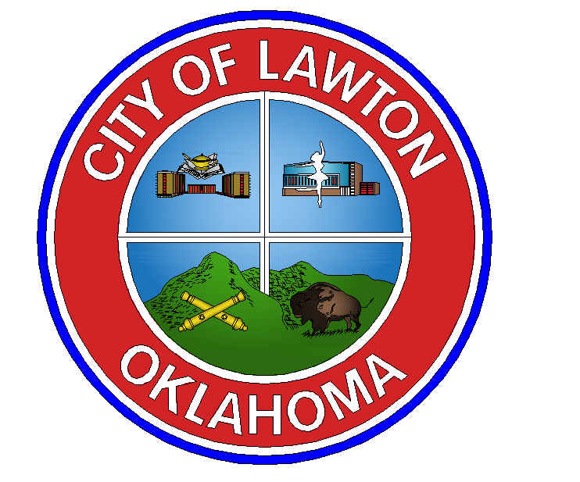
/

Office of the Mayor

212 SW 9th Street

Lawton, Oklahoma 73501

(580) 581-3305

January 14, 2025

COUNCIL BUDGET COMMITTEE:
Councilman George Gill – Mayoral Appointment
212 SW 9th Street
Lawton, OK 73501
01/01/2026

Councilman Allan Hampton – Mayoral Appointment
212 SW 9th Street
Lawton, OK 73501
01/01/2026

Councilman Bob Weger – Mayoral Appointment
212 SW 9th Street
Lawton, OK 73501
01/01/2026

BUILDING DEVELOPMENT APPEALS BOARD:
Barbara Ellis (Residential Homeowner) – Mayoral Appointment
17 SW 50th Street
Lawton, OK 73505
01/26/2027

Scott Prosser (Plumbing Contractor) – Mayoral Appointment
800 SE 1st Street
Lawton, OK 73501
01/14/2027

HISTORICAL PRESERVATION COMMISSION:
Deborah Jones (CPC Representative) – Mayoral Appointment
2920 NW Templeton Terrace
Lawton, OK 73505
01/27/2027

HISTORICAL PRESERVATION COMMISSION (CONT.):
John Jones (Licensed Real Estate Broker) – Mayoral Appointment
4301 NW Cache Road
Lawton, OK 73507
01/27/2027

HOMELESS ACTION COMMITTEE:
Stan Booker (Chairman) – Mayoral Appointment
212 SW 9th Street
Lawton, OK 73501
Council Term

Councilman Bob Weger – Mayoral Appointment
212 SW 9th Street
Lawton, OK 73501
Council Term

LAKES & LAND COMMISSION:
Mark Scott – Mayoral Appointment
4330 NW Cache Rd
Lawton, OK 73505
1/23/2028

Donald Smith – Mayoral Appointment
1101 NW 75th Street
Lawton, OK 73505
1/23/2028

LAWTON ACCESS BOARD:
Tom Love – Mayoral Appointment
7127 NW Ash Avenue
Lawton, OK 73505

LAWTON ECONOMIC DEVELOPMENT AUTHORITY:
Jason Hensley – Mayoral Appointment
PO Box 2009
Lawton, OK 73502
1/14/2031

LAWTON ECONOMIC DEVELOPMENT AUTHORITY (CONT.):
Larry Neal – Mayoral Appointment
325 NW Ridgeview Way
Lawton, OK 73505
1/14/2031

LAWTON ENHANCEMENT TRUST AUTHORITY:
Francis Dwain Baxter – Ward 8 Representative
6808 SW Oak Pointe Blvd
Lawton, OK 73505
1/14/2028

LAWTON URBAN RENEWAL AUTHORITY:
John Purcell – Mayoral Appointment
3006 NE Muse Circle
Lawton, OK 73507
7/31/2028

MAYORS COMMISSION ON THE STATUS OF WOMEN:
Cheryl Tate (At-Large City Limits) – Mayoral Appointment
7609 NW Taylor Avenue
Lawton, OK 73505
1/14/2027

Cynthia Sosa (At-Large City Limits) – Mayoral Appointment
4539 NE Bell Avenue
Lawton, OK 73507
1/23/2027

Leslie J Watts (Fort Sill Representative) – Mayoral Appointment
1828 S State Highway 65
Lawton, OK 73501
2/28/2027

MAYORS COMMISSION ON THE STATUS OF WOMEN (CONT.):
Tiera Acree (At-Large City Limits) – Mayoral Appointment
652 NW 63rd Street
Lawton, OK 73505
2/14/2027

Bernita Taylor (At-Large City Limits) – Mayoral Appointment
26 NW Sandy Trail Lane
Lawton, OK 73505
2/8/2027

PARKS & RECREATION COMMISSION:
Michael Scott – Ward 1 Representative
2406 NW Crosby Park Blvd
Lawton, OK 73505
1/1/2027

Mike Pollard – Ward 8 Representative
6504 NW Maple Avenue
Lawton, OK 73505
1/1/2027

STEM BOARD:
Mark Woommovoah – Non- Profit Representative
1117 Mount Pinchot
Lawton, Ok 73507

YOUTH & FAMILY AFFAIRS COMMITTEE:
Carl Fuqua – Mayoral Appointment
5106 NE Haddington Place
Lawton, OK 73507
UT 4/9/2027

